Name: ___________________________ ( ) Class: 2( )
Date: ____________________________
Worksheet 1

Title of the book: The seaside

- Word Hunting
Can you find these words from the book. Write them down in the boxes.

s _ _ _ _ _ _  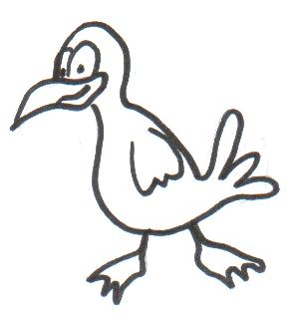  On page 1 | r _ _ _  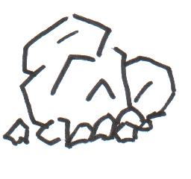  On page 3 | f _ _ _ _ _ _ _ _  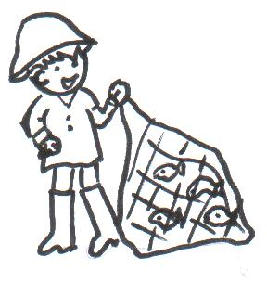  On page 5 | n _ _  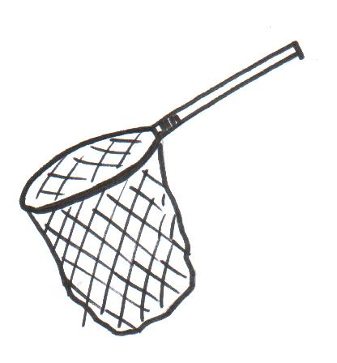  On page 7

- Answer the questions.

- I this book.

- What can you do at the seaside?

I can _____________________________________________________ at the seaside.

- Who mend the net?

___________________ mend the net.

- I can see ____________________________________________________________

_________________________________________________________ at the seaside.

Signature : ___________________
Date : ___________________

